Welcome To
15015 Danehurst Circle
Gainesville, VA 20155

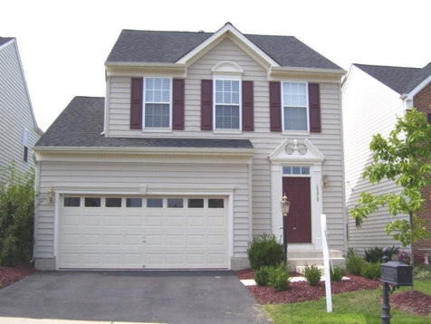
Home Sqft. | 3100
Bedrooms | 3
Full/Half Baths | 2 / 2
Living Room | 17’ x 16’
Breakfast/Sun Room | 20’ x 12’
Kitchen | 12’ x 9’
Recreation Room | 23’ x 17”
Master Bedroom | 17’ x 13’
Bedroom #2 | 11’ x 10’
Bedroom #3 | 11’ x 10’

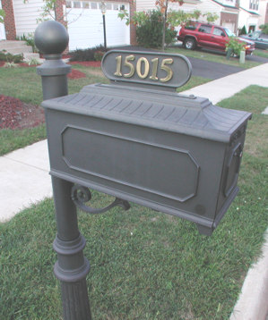

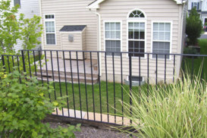

Presented By:


John Thompson

Samson Realty, LLC

14526 Lee Road, Suite 100
Chantilly, VA 20151

Cell: 703.606.0475 Fax: 703.896.5037
E-mail: John@SamsonRealtor.com
Virtual Tour: www.samsonrealtor.com

Noteworthy Features

2004-Built Ryan Homes Octavia model in the award-winning Parks at Piedmont. Located in the shadows of Bull Run Mountain and just outside the quaint village of Haymarket … yet convenient to I-66, Route 29, Route 234 and the Prince William Parkway. Multiple options for commuting via Virginia Rail Express (VRE).

- Numerous quality upgrades and options throughout, neutral decorator colors
- 3 Bedroom, 2 Full bath and 2 Half bath with finished basement
- Upgraded flooring, light fixtures, ceiling fans … Hardwood Foyer and main Hallway
- Kitchen and Breakfast Room with bumped-out Sun Room … all with Ceramic Tile
- Master Bedroom with vaulted ceiling, plant shelf and huge walk-in closet
- Master Bath with separate shower and separate whirlpool soaking tub
- Light-filled period windows throughout with high-quality plantation shutters
- Wood Deck off Sun Room and professionally landscaped yard
- Fully finished basement with Recreation Room and half bath
- 2-Car Garage with Automatic Door and Remote, Alarm/Security System installed

- Enjoy Parks at Piedmont Association membership benefits … pool, exercise room, paths, etc.
- Highly Sought Tyler ES, Bull Run MS, Battlefield HS District

- Shows great … but Sold As-Is

This wonderful Single Family Home won’t last long at this aggressive Town Home price.

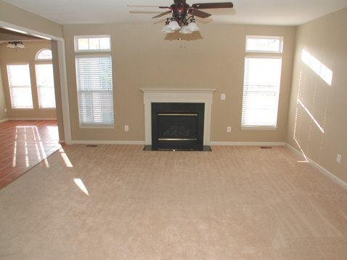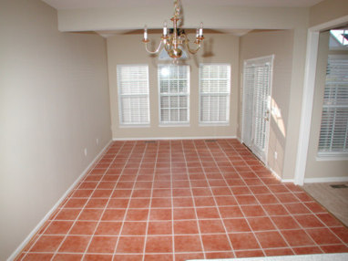

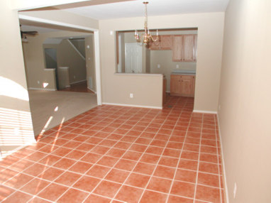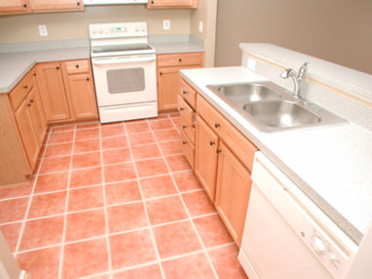

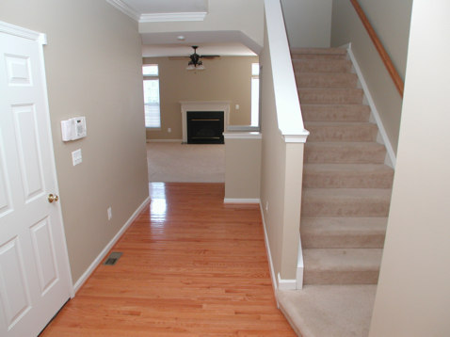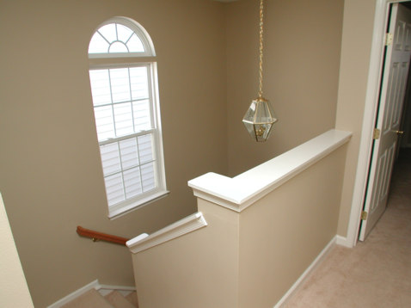

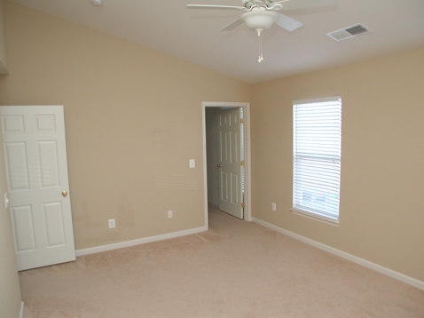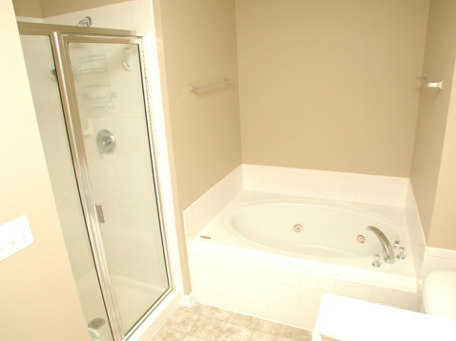

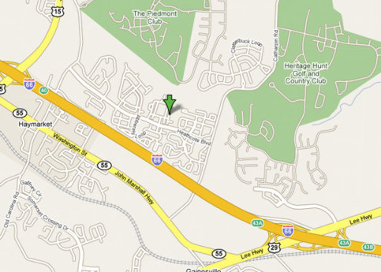

Items that Convey:
■ Stove | ■ Disposer | ■ Ceiling Fan(s) | ■ Alarm System
◻ Cooktop | ◻ Freezer | ◻ Washer | ◻ Intercom
◻ Wall Oven(s) | ◻ Window Fan(s) | ◻ Dryer | ◻ Storage Shed
◻ Refrigerator(s) #1 | ◻ Window A/C Unit(s) | ◻ Furnace Humidifier | ■ Garage Opener(s)
◻ w/ ice maker | ◻ Pool, Equip. & Cover | □ Electronic Air Filter | ◻ w/remote
■ Dishwasher | ◻ Hot Tub, Equip. & Cover | ◻ Central Vacuum | ◻ Playground Equipment
■ Built-in Microwave | ◻ Satellite Dish | ◻ Water Treatment Sys | ◻ Wood Stove
◻ Trash Compactor | ◻ Attic Fan(s) | ■ Exhaust Fan(s) | ■ Fireplace
◻ Sump Pump | ■ Window Treatments

* - All items, fixtures and entire property Sold As-Is.

Water, Sewage, Heating, and Central Air Conditioning:
Water Supply: | Public | Hot Water: | Gas
Sewage Disposal: | Public | Air Conditioning: | Electric
Heating: | Gas | Stove/Range: | Electric

All information presented in this brochure is believed to be accurate,
but is subject to errors and omissions and should not be relied upon without verification.

